First Author – Second Author [The first submission must be anonymous]
THE TITLE OF THE ARTICLE

Abstract
250–300 words. The abstract should involve a clear structure, provide a concise description of the research problem, and emphasize the results presented in the paper. English only. Text format: Times New Roman, 10-point font, italic, justified.

Keywords
3 to 5 keywords; separated; by; semicolons; English only; text format; Times New Roman; font size: 10; italic, justified

1. Introduction
Your text starts here. The article should be written in English, German, Russian or Czech. The total length of the article should not exceed 18 000–27 000 characters.
Text format: Times New Roman, font size: 12, 1.08 spacing, justified. The first line of each paragraph should be intended (except for the first paragraph in every section and the first paragraph below a figure/table/example).
The first submission must be anonymous. Do not provide your name etc. You will be asked to add this information after your paper is accepted for publication.

2. Section
Formatting requirements remain the same also in other sections. Formatting requirements remain the same also in other sections. Formatting requirements remain the same also in other sections. Formatting requirements remain the same also in other sections.
Formatting requirements remain the same also in other sections. Formatting requirements remain the same also in other sections. Formatting requirements remain the same also in other sections. Formatting requirements remain the same also in other sections.

2.1 Figures and tables
Insert figures and tables following the instructions below. First, we demonstrate how to format figures, then we show how to format tables.

2.1.1 Figures
Figures should be separated from the text in the paragraphs above and below by a line of space and centered. Do not use footnotes in figures. Refer to figures like this: Fig. 1 shows an example of a figure.
Otherwise, text formatting requirements remain the same. Formatting requirements remain the same. Formatting requirements remain the same. Formatting requirements remain the same. Formatting requirements remain the same. Formatting requirements remain the same.

Fig. 1: Figure and diagram captions should appear on the top of the image. Format: Times New Roman; font size: 11; bold; left aligned
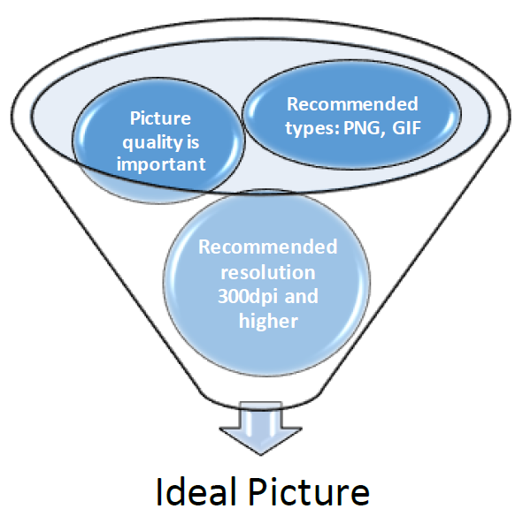

The text continues without indentation below the figure.

2.1.2 Tables
Tables should be separated from the text in the paragraphs above and below by a line of space and centered. Do not use footnotes in tables. Refer to tables like this: Tab. 1 shows an example of a table.

Tab. 1. Table captions should come on top of each table. There is no line space between the caption and the table. Format: Times New Roman; font size: 11; bold; left aligned
The row header is vertically centered and horizontally left aligned | The column header is horizontally and vertically centered
 | Table content is centered | Font size: 11

The text continues without indentation below the table.

2.2 References
References should adhere to the Harvard citation standard, i.e., parenthetical referencing format (Anonymous 1995: 12–13, 57; Anonymous – Doe 2014; 2017; Anonymous et al. 2020: 90).
Provide quotes like this: “It is very important to be precise” (Anonymous 1995: 12–13). Moreover, as first observed by Doe (2003: 99), it is very important to be concise. Finaly, Doe’s (2024) key finding is that it is important to know things.

2.3 Examples
Provide examples using tables and number them adhering to the following pattern. Use font size 11 in examples.

(1) | This is an English sentence.

(2) | a. | This is another English sentence.
 | b. | And this is yet another English sentence.

Refer to examples in the following way. As demonstrated in (1)–(2), there are English sentences. (2a) shows an interesting phenomenon. (2a)–(2b) are due to Anonymous (1995: 12). A couple of more examples are provided in (3).

(3) | a. | *This is English sentence.
 | b. | This is *(an) English sentence.
 | c. | And this is a { British / Canadian } English sentence.

Provide glossed examples using tables in the following way. Enter glossing abbreviations using small caps. We recommend using standard inventories of glossing abbreviations such as the Leipzig Glossing rules.

(3) | Das | ist | ein | deutsch-er | Satz.
 | this.nom.sg.n | be.3.sg.prs | a.nom.sg.m | German-nom.sg.m | sentence.nom.sg.m
 | ‘This is a German sentence.’ |  |  |  |  | (German)

(4) | a. | Toto | je | česk-á | vět-a.
 |  | this.nom.sg.n | be.3.sg.prs | Czech-nom.sg.f | sentence-nom.sg.f
 |  | ‘This is a Czech sentence.’ |  |  |  | (Czech)
 | b. | To | jest | polski-e | zdani-e.
 |  | this.nom.sg.n | be.3.sg.prs | Polish-nom.sg.n | sentence-nom.sg.n
 |  | ‘This is a Polish sentence.’ |  |  |  | (Polish)

The text continues without indentation below the example.

3. Conclusion
Please make sure that you have permission to reproduce all material included in your paper and that proper copyright acknowledgements are included.

Acknowledgements
Please provide acknowledgements including grant project funding and other funding information in a special unnumbered session at the end of the paper (not as a footnote on the first page).

REFERENCES
Journal articles
Anonymous, Jane – Doe, Joe. 2014. New developments here and there. Journal of Some Significance 23(2): 14–35.
Books
Anonymous, Jane. 1999. The Greatest Book Ever. Oxford: Oxford University.
Book chapters
Anonymous, Jane – Doe, Joe – Unknown, Scholar. 2020. Another joint paper. In: Unfamiliar, Researcher – Unknown, Scholar (eds.), New Findings in Our Field, 86–99. Cambridge, MA: MIT Press.
Papers in proceedings
Anonymous, Jane – Doe, Joe. 2017. This definitely doesn’t work but we still had to make the deadline. In: Unfamiliar, Researcher – Unknown, Scholar (eds.), Proceedings of Last-minute Research 13, 101–107. Brno: Masaryk University.
Theses
Doe, Joe. 2003. The Groundbreaking Thesis. Brno: Masaryk University. URL: http://thegroundbreakingthesis.edu.com
Unpublished
Doe, Joe. 2024. We have absolutely no idea. Unpublished manuscript. Brno: Masaryk University. URL: http://jane.anonymous.com/we-have-absolutely-no-idea-v.2024.pdf

First Author [The first submission must be anonymous]
English Name of the Institution
Address
first.author@email.com

Second Author [The first submission must be anonymous]
English Name of the Institution
Address
second.author@email.com

This is a footnote (Times New Roman, font size: 10). Please avoid long footnotes.
In references use Roman characters only. References using other scripts, e.g., the Cyrillic script, must be transliterated.

